**Khwopa Engineering College**

**i sEMESTER ASSESSMENT - 2012 (ODD)**

lEVEL:- B. E. (Computer/Elx. & Comm.) I/I

SUBJECT:- BEG145ME, Engineering Drawing

FULL MARKS:- 40

TIME:- 03:00 hrs. 2068-12-24 PASS MARKS:- 16

*Candidates are required to give their answers in their own words as far as practicable.*

*The figures in the margin indicate full marks.* Assume dimensions if necessary.

**Attempt ALL questions.**

1. Draw a cycloid, given the diameter of generating circle as 40 mm. 5
2. A line MN 60 mm long has its end M 30mm above HP and 20mm behind VP. The line is parallel to VP and inclined to HP at 300. Draw its projection. 6
3. Draw the complete orthographic projection of the object shown below with front view being fully sectioned. Dimension it completely. 15
4. Develop the complete surface of the solid cut by two planes as shown below. Dimension it completely. 14

**OR**

1. Draw the given views of assigned form and complete the intersection. Dimension it completely. 14

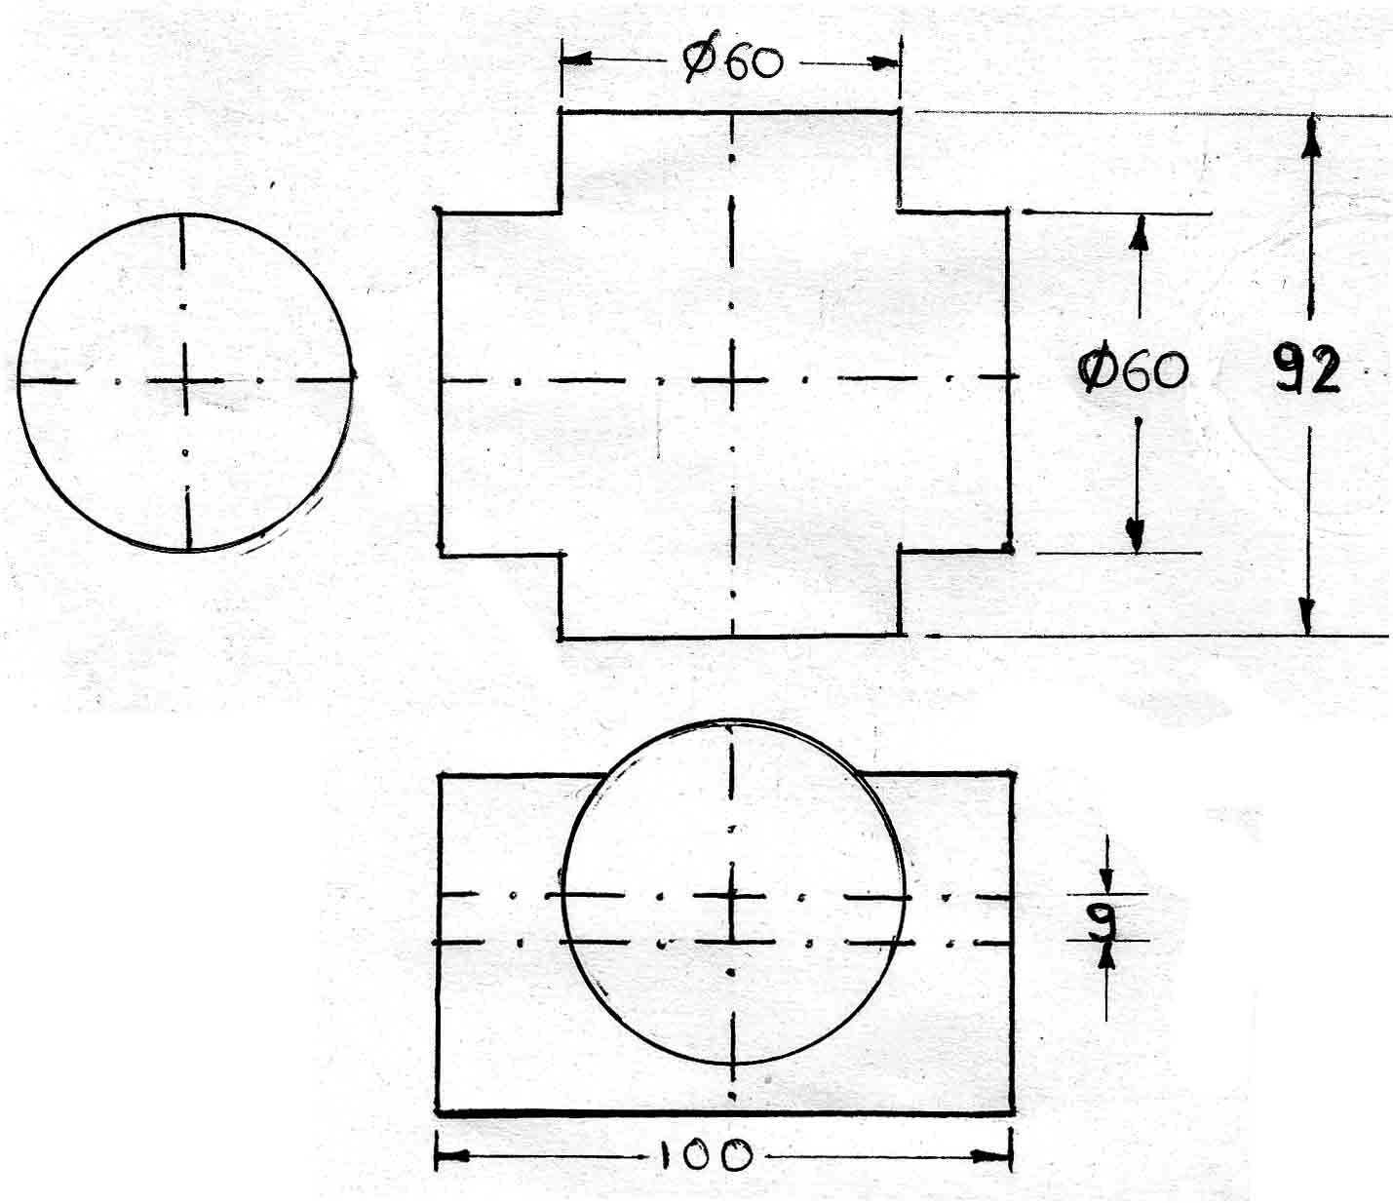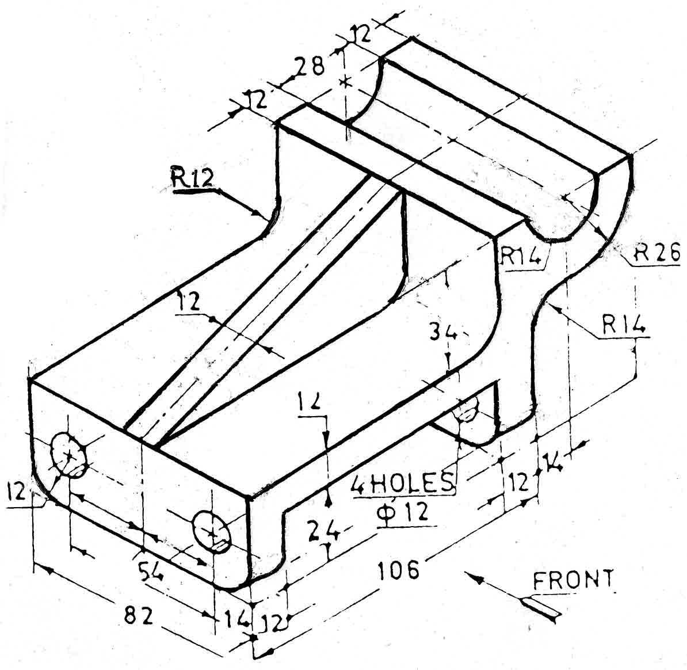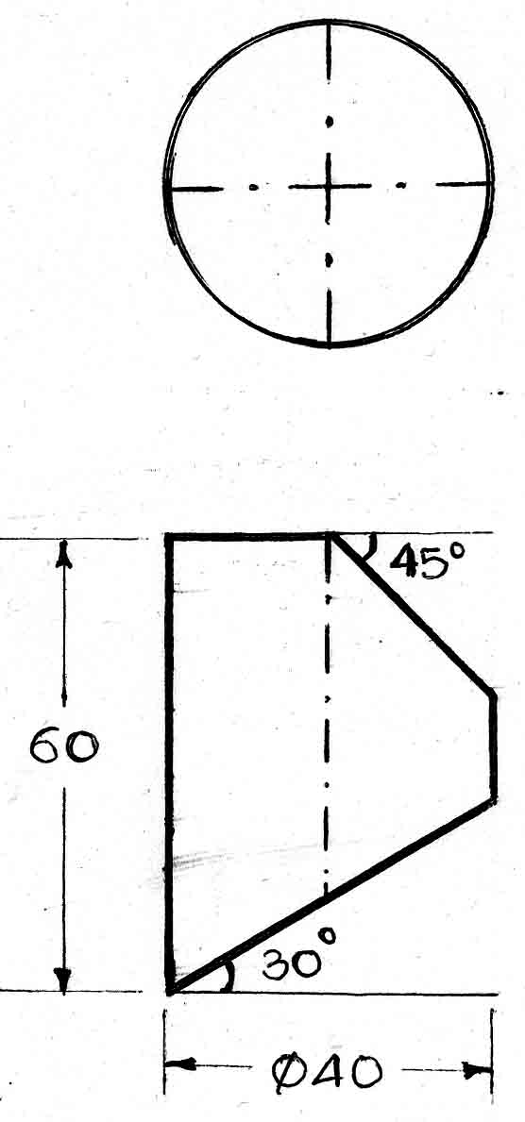

Figure for Q.No.3. Figure for Q.No.4. Figure for Q.No.5.

***